Practical No:09
Aim: Design & verify the operation of JK flip-flop using logic gates.

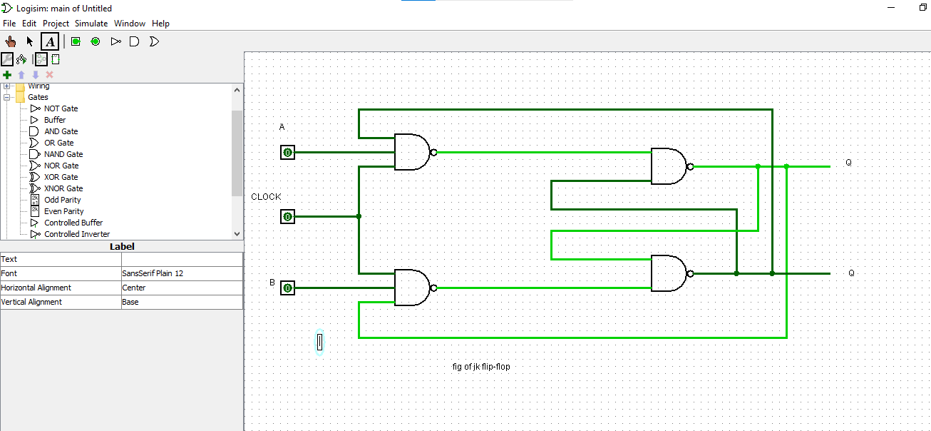

Name: Roshan dhaigude
Sub: Digital System & Architecture
Class:FYBs CS
Roll no:
Sign:

